2014 Chemistry Periodic Table Notes
Antoine Lavoisier (1700’s)
- Listed all known elements (33) at the time
- 4 groups: _____________,____________, ___________ and _____________.

Dobereiner (early 1800’s)
- Arranged the elements into _______ (groups of three elements) based on __________ in properties.
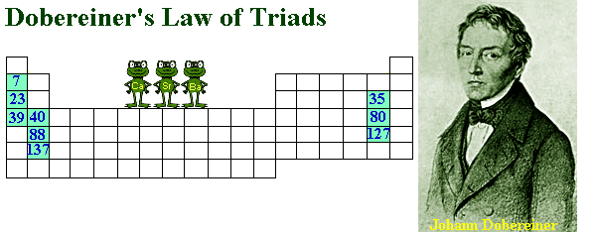
John Newlands (1864)
- Arranged elements by increasing atomic ________. (70)
- Noticed a ___________ pattern of ____________.
- Created the ________________________ (repeating patterns at every eighth element)
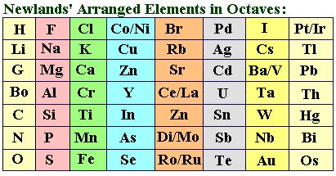
Lothar Meyer (1869)
- Identified and proved that there was a connection between ________ ________ and the ________ of the element
- Arranged the elements by increasing atomic mass (added the ________ ________)

Dmitri Mendeleev (1869)
- Proved a __________ between atomic mass and element properties
- Arranged elements by increasing atomic mass
- Predicted the ___________ and __________ of elements yet to be ___________

Henry Moseley (1913)
- Discovered atomic _______________
- Arranged elements by increasing atomic number
- By doing this a pattern of properties was discovered and fixed previous problems
Periodic Law
- When elements are arranged by increasing atomic __________, there is a periodic repetition of ___________and ____________ properties.
- Modern Periodic Table:
  - __________ (rows)- contain a variety of elements ranging from metals to nonmetals to Noble gases. There are __________.
- __________ or __________ (columns)- contain elements that share similar properties. There are ________.

Representative (Main) Elements:
- Marked by “_____” on most groups.
- Elements in the _______ and ________ block
- _____________ range of characteristics
- This is ______________ ____________________

Transition Elements (B) Consists of only metals.
- Found in the ___________________ of the period table.

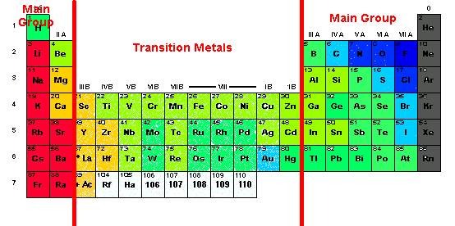
Metals, Nonmetals, and Metalloids
Metals:
- Make up ___________ of the periodic table
- ________ at room temperature (except __________)
- Good conductors of _________and _____________
- ____________ and _____________
- Have Luster (____________)

Nonmetals:
- __________ or _________ at room temperature (except ________, it is a liquid)
- ___________ conductors of heat or electricity
- _____________
- Dull

Metalloids:
- ____________ of characteristics of both ___________ and nonmetals
- ______, ________, ________, _________, ________, _________, _________, _______
- Silicon and Germanium are both used in computer chips
S- Block:

- Alkali Metals
  - 1 valence e-. This makes them highly ____________
  - Exist only as ____________
  - Silvery white in color
  - Often bond with ______________
  - Used in salts and batteries
  - Forms _________ with a ________ charge

- Alkaline Earth Metals
  - 2 valence e-. Makes them highly reactive
  - Ca and Mg are important components of living cells
  - Silvery in color
  - Used to make laptop casings
  - Forms ions with a ________ charge.

P- Block (Families 13-18):

- Boron Family (13)
  - 3 valence e-
  - Tends to _________ its valence e- away
  - Most are ____________
  - Not as ____________ as group one and two
  - Forms ions with a 3+ charge

- Carbon Family (14)
  - 4 valence e-
  - Can either _________ __________ its valence electrons or take additional electrons
  - Sn and Pb will form ions with 4+charges

- Nitrogen Family (15)
  - 5 valence e-, but will form _______ (it prefers to _______ 3 e- rather than ____ away 5)
  - N and P are reactive and found in many molecular compounds

- Oxygen Family (16)
  - 6 valence e-
  - Forms 2- ions. It prefers to gain_________ 2 e- rather than give away 6)
  - O and S are reactive and found in many compounds

- Halogens (17)
  - 7 valence e-
  - Form 1- ions (gains 1 e-)
  - Highly reactive ____________
  - Will often bond with metals to make ________

- Noble Gases (18)
  - 8 valence e-, full p ___________
  - Does not form ions
  - Inert gases (__________)
  - They do not __________ with other elements because they do not need any more e-.

D- Block (3-12)
- All ____________ metals
- Most are hard metals
- All can exist as _________ elements in nature
- Will form a variety of _________ ions due to the fact that the s and d sublevels are close in energy amounts

F- Block (Period 6 and 7)
- Lanthanide Series
  - elements 57-70
  - Fits in period _______
  - Shiny metals
  - Highly ___________

- Actinide Series
  - elements 89-102
  - Fits in period _________
  - Radioactive
  - The first 4 are naturally occurring the rest are lab created

** For the Lanthanides and Actinides: Electrons fill the f-orbitals in an ____________ manner and there are many ___________ to electron configuration rules.

Octet Rule: Every Element wants _____ valence e-

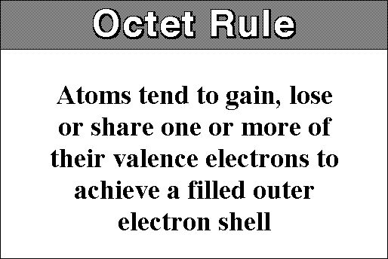

Formation of Ions:
- A positive ion (called a __________) results when an atom _________electrons.
- A negative ion (called an ___________) results when an atom ______ electrons.

Periodic Trends:
- Patterns in the periodic table that can be determined by __________ a period or a group
- ____________, _______________, ______________, __________________

Atomic Radius:
- The “__________ of atom”
- The outer edge of an atom is not clearly defined; there is no definite edge
- Atomic radius is therefore ________ the distance between two identical nuclei
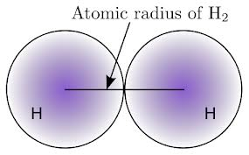

Atomic Radius Trend:
- __________as you go __________ the period - as you go across a period, more ___________ in nucleus, greater positive charge. Added __________ in ______principal energy level, so they get pulled closer to nucleus.
- _________ as you go down the ________ – as you go down a group, more ________ are added increasing nuclear charge. However added electrons are in successively _______ energy levels which are _______ from the nucleus.
- Electrons are _________ pulled as tightly toward the nucleus.
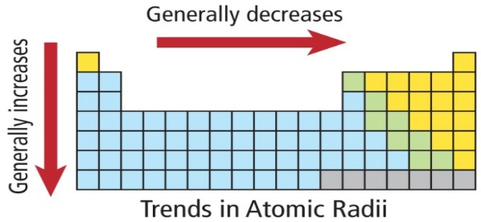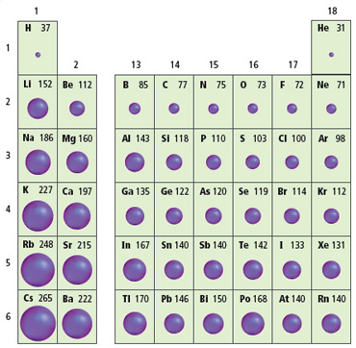

Electronegativity:
- the ability of an atom to _________ an electron while in a __________ bond
- the larger the electronegativity value, the _________ an atom is at _______ electrons while in the chemical bond
Electronegativity Trend:
- _______across the period – atoms are smaller going across a period, _______shell is closer to being full, and it is closer to the ______ nuclear charge
- Decreases down the _______ – atoms are larger going down a group, outer orbitals ________ from positive nuclear charge, not good at attracting electrons

