Graphing in Science

1. **Bar Graph**- used to ____________ data/quantities

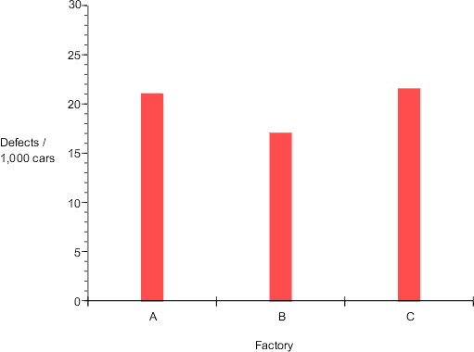

2. **Circle/Pie** **Graph**- used to show _______________

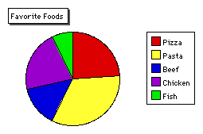

3. **Line Graph**- used to show a trend over a **_________** of time or a __________ between two variables.

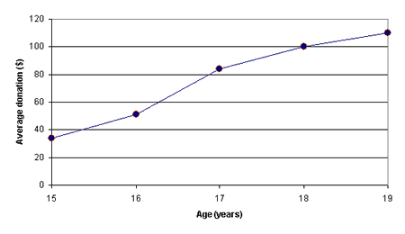

Remember to:

* ALWAYS label ________ axis, include __________.
* Scale your axis numbers to use ____ of the graph, using the most appropriate increments.
* Draw a best fit line.
* ___________ your graph
* Make a ______ for data if needed. (more than one __________ on a graph)

Quick Way to Remember how to build a Graph

* __________________________
* This is an acronym for graphing
* D-__________________, R-responding, Y-______________
* M-manipulated, I- ________________, X-axis