States of Matter - Solids, liquids, Gases
Review of Ionic vs Covalent Bonds
Ionic:
- _________ and ___________
- __________ of electrons
- __________ bond
Covalent:
- Nonmetal and ___________
- __________ of electrons (equal or _________)
- ___________ bond
States of Matter:
- Forces other than chemical _________ determine if a substance is a solid, liquid or gas at ______ temperature
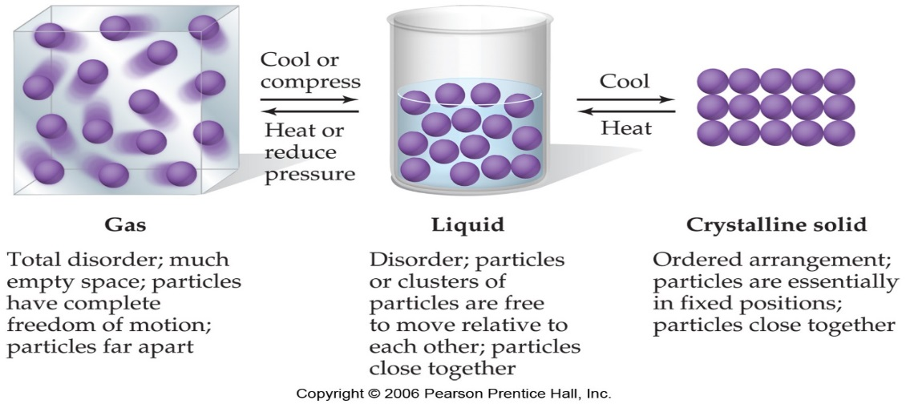
Intermolecular forces:
- Intermolecular forces are how one _____________ interacts with the molecule next to it.
- It is not an interaction between ___________, that is a BOND (ionic or covalent).
- Intermolecular forces are _________ than bonds between atoms

Dispersion forces- weak attractions due to shifts in the ___________ that are in the electron cloud.
- These are ___________ forces
- Example: Dry ice
Carbon dioxide is a gas at room temperature yet when the temperature is ________ enough the particles will have enough __________ for each other to come close together and form a _______.
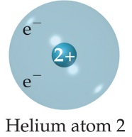
- The electrons in the __________ level of helium ________ each other (so tend to stay far away from each other), occasionally wind up on the same __________ of the atom.
- At that instant, the helium atom is _________, with an _________ of electrons on one ____ and a shortage on the other side.
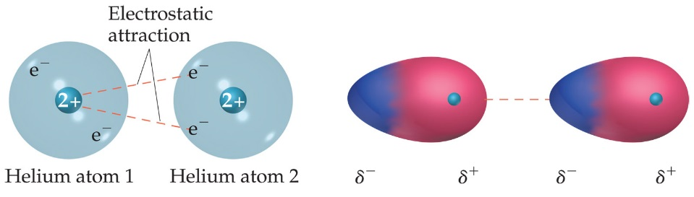
- Another Helium nearby would be __________ to the “polar” Helium. Remember – it is only a
temporary arrangement – the electrons are still ______________!
- These forces are __________ forces
- Exist mainly between __________ gas atoms and _________ molecules
- The strength of dispersion forces ___________ with increased molecular weight.
- (bigger atom/molecule = ___________ force)

Which has the stronger Dispersion force?
- Cl₂
- Br₂
Which has the stronger Dispersion force?
- He
- Ne
- Ar
- Xe
Which has the stronger Dispersion force?
- CH₄
- C₂H₆
- C₄H₁₀

Dipole-Dipole Forces - form between 2 ___________ molecules.
- Remember polar molecules have an area that is ____________ positive and __________ negative due to ___________ in the bond that holds the atoms together
- Example: HCl
The positive end of one is attracted to the ____________ end of the other and vice-versa.
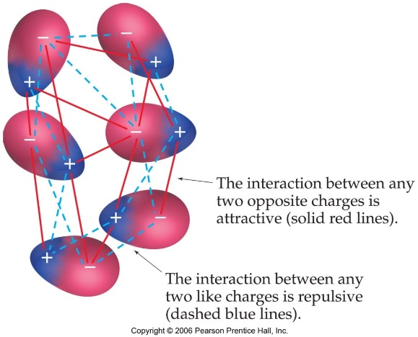

Which of the following molecules have dipole-dipole forces present?
- NH₃
- CH₄
- Both

Hydrogen bonds - form when both molecules contain _____________ and either _____, _____, or ____.
- Are unusually ________ forces
  - Example: (H₂O)
- Water is ________. The interaction occurs when the negatively charged oxygen on one water molecule is attracted to the ________ charged Hydrogen on a different water molecule.

Which of the following compounds has hydrogen bonding present?
- H₂S
- H₂O
- Both

Properties of Liquids
1. Surface Tension
- __________________-Resistance of a liquid to increase in surface area
- Measure of the __________________ forces
- Liquids with high intermolecular forces have _________ surface tensions
- Describe an example of Surface Tension:

2. Capillary Action
- Spontaneous _______________ of a liquid in a narrow tube
- Caused by _______________ and _________________ forces
cohesive forces-intermolecular forces _____________________ liquid molecules
adhesive forces- force between the liquid molecules and the ________________; occur when the container is made of a _____________________ substance

Example of Capillary Action
When water is placed in a glass graduated cylinder, the meniscus is concave
____________________ forces > _____________________ forces (glass is __________)
When mercury is placed in the same graduated cylinder, the meniscus is convex
___________________ forces > __________________forces (mercury contains only dispersion forces-______________________)
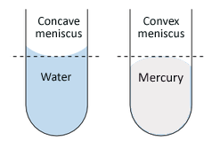

3. Viscosity
- A ______________________ to flow
- Strong intermolecular forces result in ________________ viscosity
- Large molecules also have high viscosity due to _________________________ forces
- As temperature increases, viscosity ___________________________

4. Vapor Pressure
- Pressure of vapor ____________________ the surface of a liquid
- Caused when the molecules on the surface break away and go into the ___________phase
- In order to break away, the molecules must possess a _____________ amount of kinetic energy
- High intermolecular forces result in _____________ vapor pressures
- Volatile liquids are liquids that evaporate ____________ resulting in ________ vapor pressures
- Substances with weak intermolecular forces tend to be _________________
- As temperature increases, vapor pressure ___________ (more molecules possess the minimum ______________________ and the rate of evaporation increases)

