BOHR MODEL 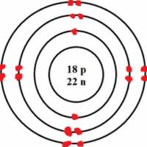

ELECTRON
CONFIGURATION 1s²2s²2p⁶3s²3p⁶4s²3d¹⁰4p⁶5s¹

ORBITAL DIAGRAM

1s
2s
2p
2p
2p
2p

ELECTRON DOT 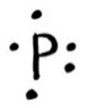
NOTATION

NOBLE GAS
NOTATION

